SCQF Level 8
Sample Examination Paper

1. On the manuscript paper provided, write from memory four parts of one of the tunes submitted for the Light Music (Ceol Beag) practical examination.
Marks 30

2. On the manuscript paper provided, write out the following Piobaireachd movements (in full):

- An Endari.
- An Edre from High G.
- A Dare from C.
Marks 6
3. On the manuscript paper provided, write out FOUR bars of each of the following:

- A Dithis Singling
- A Crunluath Breabach Doubling (in full)
- A Crunluath a Mach (in full)
Marks 15

4. In Piobaireachd Classification what does the Tune Title tell us?

Marks 4

5. Explain fully what is meant by Pentatonic Scales and how many different keys are used in bagpipe music. Give examples of the notes used in each key.
Marks 8

6. What are the seven categories of Phrase Construction used in Piobaireachd?

7. Give two different examples of Phrase Construction from your submitted tunes for the Ceol Mor practical examination.
Marks 10

8. Write out in Nether Lorn Canntaireachd the notes of the G gracenote scale.

Marks 5

9. Translate the following passage of Piobaireachd staff notation into Nether Lorn Canntaireachd.
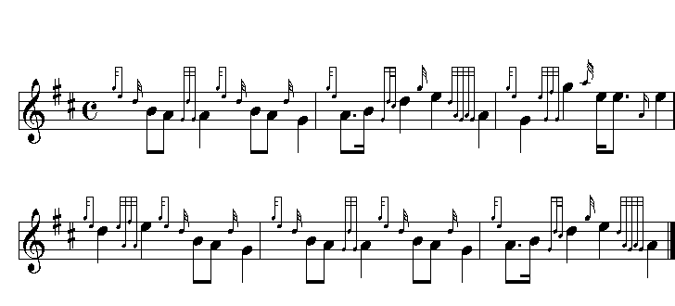

Marks 15

Total Marks 100

