**PIPING & DRUMMING QUALIFICATIONS BOARD**

**LEVEL SEVEN CERTIFICATE PIPING**

# THEORY PAPER (A)

## Time Allowed: 2 hours

**Answer all questions.**

1. Describe the difference between relative and absolute pitch referring to the two systems for measuring them.

**4 marks**

2. What is a pentatonic scale? What are the pentatonic scales available on the Highland bagpipe chanter?

**8 marks**

3. You will see below the numbers 1 to 8 representing the notes of a scale. Below and in between the numbers of the notes, write out the arrangements of tones and semitones in a standard, western major scale and then immediately below write out the arrangement of tones and semitones for the bagpipe scale?

**1 2 3 4 5 6 7 8**

Western Major

Bagpipe

**7 marks**

4. Draw out the Great Staff and show the pitch of the tenor drone, bass drone and all of the notes on the bagpipe scale.

**6 Marks**

5. What key signature would another instrumentalist have to play the following piece of music, to accompany you on the pipes?

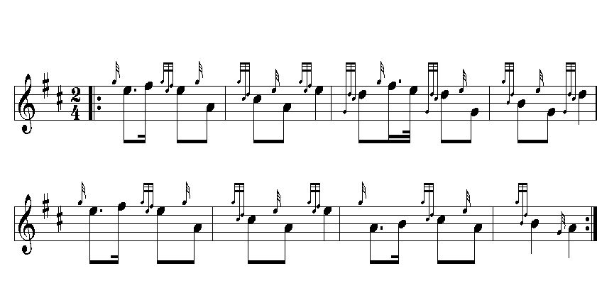

**1 Mark**

6. Compose a bagpipe harmony to the supplied piece of music.

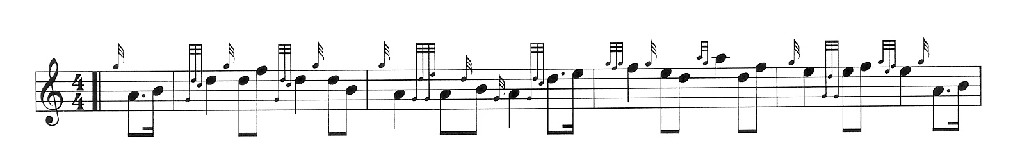

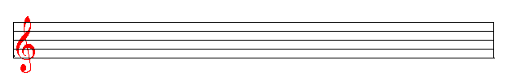

**8 marks**

7. Write on the stave below the first line of the urlar or ground of a piobaireachd.



10 Marks

8. State the playing requirements and format for the Highland Fling. Name two suitable tunes, the number of bars required to complete the dance, and suitable tempo.

**6 Marks**

9. Write a short essay of not more than 500 words on one of the following topics:

The solo competition system

The pipe band movement

A famous piper and his/her contribution to piping

A present day piping organisation and its contribution to piping

**10 Marks**

TOTAL / 60